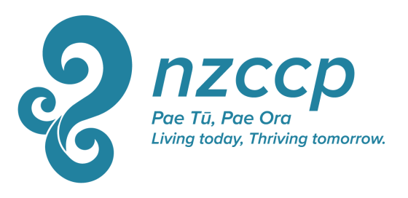

NZCCP Research/Study Award

Description: This award of up to $8,000 is offered annually to a full or associate member of the College to assist to them to undertake travel or a similar specific activity to further their education or interest in a clinical or research activity related to clinical psychology. The grant may be used to fund travel, accommodation, a daily allowance, or other expenses directly related to the above purpose, as detailed in their application.

Criteria: Preference will be given to applicants who specify clear learning and or skill-development outcomes from the activity (e.g., developing a specific new skill set rather than merely attending a conference). Other criteria on which applications will be assessed include.
- Relevance of proposed learning to the applicant’s role as a Clinical Psychologist
- Relevance of proposed learning to NZ Clinical Psychology community

Feedback: Recipients of this grant will be expected to share their learning with the national membership of the NZCCP through at least one activity such as giving a paper or workshop at the NZCCP conference or writing an article or report for the Journal of the New Zealand Journal of Clinical Psychologists or ShrinkRAP. Any such written work does not need to be particularly lengthy or academic, but needs to convey to the membership what the recipient has learnt in such a way that the membership may also learn something of value from the grant. For more information download the guidelines for authors here.

Application Process: Calls for applications will be announced during December via e mail, in appropriate NZCCP publications such as ShrinkRAP, and by posting on the NZCCP website. Applications should be completed on the study grant form and submitted with requested supporting documentation to the College Executive Director by the end of February of the following year.
The National Executive will select a minimum of two reviewers to review all proposals, and on the basis of feedback from these reviewers, the National Executive will select the successful recipient. The National Executive’s decision is final.
The successful recipient will be informed by the end of March.
Unsuccessful applicants are not precluded from reapplying in the future.

Application Form: NZCCP Research/Study Award

Name:
Address
Phone
Mobile
E mail

Describe what you wish to use the NZCCP Research/Study Grant to do: (200 word maximum)

What are your expected learning outcomes from the activity described above? (200 words maximum)

How will undertaking this activity change, extend, or otherwise contribute to your practice, research, understanding, or work as a clinical psychologist? (200 words maximum).

If you are the successful recipient of the NZCCP Research/Study Grant, how do you intend to feed back what you learn so that other members of the College may also learn from it? (e.g. workshop or paper at the National Conference, article or report in the Journal or ShrinkRAP) (200 words maximum)

What expenses are you seeking this grant to cover? (Maximum total = $8,000)
Description of Expense | Amount
Total Requested

What is the total sum that you expect participation in the activity you are applying for will cost for you to undertake? $___

Have you sought funding support from anywhere else to undertake this activity? If so, please give details.

Notes: NZCCP Research/Study Award

- If you are applying for a course, workshop, training programme, or similar, please supply a copy of the brochure, registration material, or other similar information describing the contents.
- If you are travelling to study with or visit a particular practitioner, please provide a biography of that person and a description outlining the contribution they have made to the field. If possible, please also provide a letter from that person indicating their agreement for you to study/visit with them.
- Any air fares purchased with this grant must be an economy fare. With travel and other expenses, please quote for and endeavour to obtain goods and services that are as inexpensive as reasonable while meeting your reasonable needs.
- Cost over-runs from the quoted budget will be met only at the discretion of the NZCCP. The total budget amount of $8,000 will not be exceeded.

