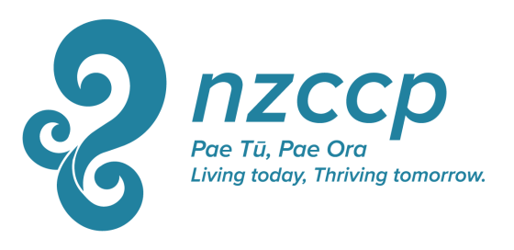

The Cyclone Gabrielle Grant
Description:
In recognition that the aftermath of the cyclone Gabrielle has created ongoing difficulties for psychologists in the affected areas, possibly including more difficulty than usual with funding continuing educational activities, a special grant has been established by the NZCCP National Office for a period of 2 years (2023-2024).

The grant is offering 5 x $500 subsidies for NZCCP members (of any category) currently living and working in areas that have been affected by the cyclone Gabrielle.

The purpose of the grant is to support NZCCP members who have been affected by cyclone Gabrielle to attend Continuing Educational activities relevant to their profession.

The grant has a total value of $2500 per annum and is distributed as 5 grants of $500 each per year.

Criteria: Criteria for eligibility and selection for these grants include:

- Being a resident or working in the area affected by the cyclone (Northland, Auckland, Coromandel, Gisborne, Hawke's Bay and Manawatū-Whanganui)

- That you are applying for funding to attend a continuing educational opportunity relevant to your work as a clinical psychologist (the grant can either cover registration and/or travel associated with attending an educational opportunity)

Application Process: Calls for applications will be announced in June by email and on the NZCCP website. Applications should be completed on the grant application form and submitted with any requested supporting documentation to the College Executive Director by the first week of August.
Successful applicants will be chosen by lottery from all eligible applications using the criteria above.
The successful recipients will be informed by the first week of September.
Unsuccessful applicants are not precluded from reapplying in the future.

Application Form: The Cyclone Gabrielle Grant

Name:
Address
Phone
Mobile
E mail

Declaration:
- I am a resident/I am working in the area affected by the cyclone (Northland, Auckland, Coromandel, Gisborne, Hawke's Bay and Manawatū-Whanganui)
YES/NO

Describe what you wish to use the Cyclone Gabrielle Grant to do: (200 word maximum)

How is this relevant to your work as a clinical psychologist? (200 words maximum)

