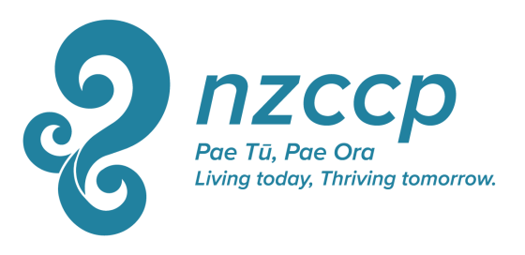

The Susan Selway Memorial Scholarship

Description:
In recognition that the aftermath of the earthquakes in Christchurch has created ongoing difficulties for psychologists working in Christchurch, possibly including more difficulty than usual with funding continuing educational activities, a special scholarship was established by the NZCCP Auckland Branch jointly with the National Office for an initial period of 5 years (2011 - 2015). As the situation in Christchurch continues to present difficulties the NZCCP Council has extended the Susan Selway scholarship, offering 3 x $400 scholarships, which will now be entirely national office funded, for a further 5 years (2016 – 2020) for NZCCP members (of any category) currently living and working in Christchurch.

The purpose of the scholarship is to support NZCCP members from Christchurch to attend Continuing Educational activities relevant to their profession.

This scholarship has been named The Susan Selway Memorial Scholarships, in honour of Susan Selway, a clinical psychologist and College member, who was killed in the 22 February 2011 earthquake.

This scholarship has a total value of $1200 per annum, and is distributed as three grants of $400 each per year.

Criteria: Criteria for eligibility and selection for these grants include
- Being a resident or working in the Christchurch area
- That you are applying for funding to attend a continuing educational opportunity relevant to your work as a clinical psychologist.
- That you have not received the scholarship within the previous two years, unless insufficient other applications are received.

Application Process: Calls for applications for will be announced during December via e mail, in ShrinkRAP, and on the NZCCP website. Applications should be completed on the grant application form and submitted with requested supporting documentation to the College Executive Director by the end of February of the following year.
The successful applicants will be chosen by lottery from all eligible applications using the criteria above.
The successful recipient will be informed by the end of March.
Unsuccessful applicants are not precluded from reapplying in the future.

Application Form: The Susan Selway Memorial Scholarships

Name:
Address
Phone
Mobile
E mail

Declaration:
- I am a resident/I am working in the Christchurch area YES/NO

- I have not received the scholarship within the previous two years. YES/NO

Describe what you wish to use the Susan Selway Memorial Scholarship to do: (200 word maximum)

How is this relevant to your work as a clinical psychologist? (200 words maximum)

